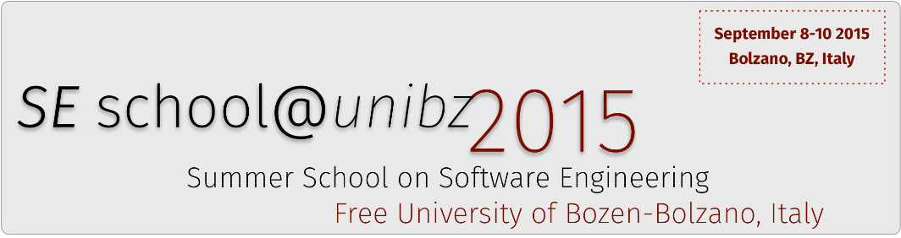

__________________________________________________________________________________

**CERTIFICATE OF PARTICIPATION**

We hereby certify that

**Riccardo Roveta**

**Has passed the exam for the courses**

1.Code Smells Identification and Refactoring Automation: Challenges, Solutions, and Open Issues

2. Get Your Hands Dirty with Mining Software Repositories in 180 Minutes

of the

**Summer School on Software Engineering 2015**

**held at the Free University of Bolzano on 8 - 10 September 2015.**

**__________________________________________________________________________________________**

**Barbara Russo Gabriele Bavota**

(Posizione)(Posizione)

